ARIA: AI for Reserving, Indications and Analysis–Design and Empirical Evaluation of an Actuarial Coding Agent
Hugo Latendresse Sabrina Tan

Abstract
Interest in AI agents has raised the possibility of using them to support actuarial ratemaking and reserving work. This paper describes the design and evaluation of an actuarial AI assistant that targets end-to-end ratemaking and reserving workflows. The assistant is implemented as a fork of Cline (a VS Code coding agent) and is specialized at run time using an actuarial system prompt, method-specific capability cards, and optional document lookup via retrieval-augmented generation (RAG) from the exam source texts. We evaluate performance using an automated test suite derived from textbook case studies, including 61 unit tests and 8 end-to-end integration tests. Unit accuracy improves materially with domain guidance: pass rates increase from 64% out-of-the-box to 95% with capability cards. Integration reliability also improves but remains limited: pass rates increase from 0% out-of-the-box to 50%. Repeated runs show meaningful variability; for capability cards + RAG, integration pass rates range from 38% to 63% across five trials. Overall, the assistant can accelerate implementation and automate repeatable steps, but longer and/or more complex workflows still require actuarial oversight.

1. Introduction

1.1 Background
This project focuses on developing an AI-based tool (Aria) that can execute P&C actuarial work, with scope focused on CAS Exam 5-level ratemaking and reserving workflows based on the latest editions of Basic Ratemaking (Werner and Modlin, 2016) and Estimating Unpaid Claims Using Basic Techniques (Friedland, 2010). These references are referred to in this paper as “exam source texts”. The goal is to build an assistant that can ingest standard actuarial inputs, implement common methods end-to-end, and provide analysis and results in a form that an analyst can inspect and reuse.
We implemented the assistant by forking and extending Cline, an open-source coding agent available as a VS Code extension. Implementing the assistant in VS Code means it produces standard Python code and artifacts that are easy to review, run, and version-control via git. The design allows the tool to benefit from ongoing updates to Cline and from improvements in large language models (LLMs) as Cline is model-agnostic. Additional details on platform selection and design goals are provided in Section 2.2.
Rather than fine-tuning a model, we specialize the general coding agent using run-time guidance: an actuarial system prompt, method-specific capability cards (procedural templates and code patterns), and optional document lookup (RAG) from the exam source texts. These components aim to improve calculation accuracy on the automated test suite and produce outputs that can be reviewed and rerun. The design of these actuarial specialization configurations is described in Section 2.2.2.
Finally, we evaluate the tool’s performance, accuracy, and run-to-run consistency using case studies from the same reference texts. These case studies provide sample datasets, step-by-step procedures, and benchmark outputs suitable for automated scoring, to allow for comparisons across configurations and clearer diagnosis of where failures occur. The test suite and scoring approach are detailed in Section 2.3, with empirical results reported in Section 3.

1.2 Contributions
This research project makes four main contributions:
- A reproducible actuarial evaluation suite. We curate a set of integration tests (full end-to-end case studies) and unit tests (stepwise decompositions of the case studies) from the examples in Friedland and Werner-Modlin, along with automated scoring scripts. This provides a way to assess both step-level calculation and end-to-end workflow accuracy. Instructions to access the test harness repository are provided in Appendix C.
- An actuarial AI assistant built as a VS Code extension. We implemented the assistant by forking and extending Cline, so it runs inside VS Code and produces Python code that can be reviewed, rerun, and tracked with version control. The assistant is also model-agnostic (“bring your own API key”), so it can benefit from improvements in LLMs over time. Instructions to install the tool are detailed in Appendix A and the guide to access its source code in Appendix B.
- Actuarial specialization without fine-tuning. We implemented three domain-guidance mechanisms that can be applied at run time: an actuarial system prompt (global role and workflow expectations), capability cards (method-specific procedural templates, formulas, and code patterns) and optional document lookup via retrieval-augmented generation (RAG) from the exam source texts. These provide actuarial guidance to the tool.
- An empirical comparison of configurations. We compare four configurations (out-of-the-box, system prompt only, capability cards only, and capability cards + RAG) on both unit and integration tests. The results quantify the improvement gained by each configuration and the gap between stepwise and end-to-end accuracy. Three case studies highlight common failure modes and practical findings on AI agent performance on longer actuarial workflows.
The remainder of this paper is organized as follows. Section 2 describes the project scope, design of the actuarial AI assistant, and the evaluation methodology for unit and integration tests. Section 3 presents empirical results across configurations, including run-to-run consistency and case studies that illustrate common failure modes. Section 4 discusses practical implications, limitations, and opportunities. Supplementary technical details and reproducibility instructions are provided in the Appendices.

2. Methods
This section details the development and validation of the actuarial AI assistant. We first define the specific scope of the tool. We then describe the system architecture, explaining how we extended an open-source coding agent with domain-specific guidance–such as capability cards and document retrieval–to generate code that an actuary can inspect, edit and reuse (Section 2.2). Finally, we detail the evaluation framework used to assess the system's performance (Section 2.3).

2.1 Scope
This project focuses on developing an AI-assistant that can automate a broad set of reserving and ratemaking tasks. Our AI-assistant is a chatbot that can do the following:
- Interact with the user to collect inputs, instructions and assumptions.
- Look up relevant actuarial literature when needed.
- Load required data and inputs.
- Read, write, edit, and run Python code that implements actuarial calculations to produce numerical results.
- The generated analysis is reproducible: the scripts are saved in a persistent project directory accessible to the user, can be rerun (and edited) by the user, and are version-controlled.

The space of problems such a tool can solve is, by design, very large. To help guide development, we focused on a finite set of well-defined workflows with worked examples and verifiable outputs; we chose a subset of CAS Exam 5 methods for our evaluation. Those specific reserving and ratemaking procedures were used as the basis for our unit and integration tests and are described in Section 2.3.

Out of scope. We did not attempt to cover broader real-world production complexity such as large-scale policy/claim transaction datasets, data cleaning, or company-specific pricing/reserving data segmentation and schemas. We also did not test robustness across different aggregation levels, file formats, lines of business, or data with quality issues (e.g., missing fields, inconsistent coding, partial histories). These areas were largely out of scope because this would require access to representative anonymized insurer datasets–E.g. premium/exposure data at the policy level and loss data at the claim or claim-coverage level.

2.2 System Design and Implementation

2.2.1 Platform selection and tool design
Building on top of an AI coding agent. Many of the engineering features needed to meet our goals–editing files, running code, debugging, and keeping an auditable history of changes–are now standard in AI coding tools. Rather than re-building those components, we leveraged existing tools and focused our effort on implementing the required actuarial knowledge.

AI tool evaluation and platform choice. During the development period, IDE-based AI coding tools were becoming mainstream. We therefore looked for an approach that would (a) work inside a familiar development environment, (b) produce normal Python files that an actuary can inspect and edit, and (c) avoid turning the actuarial calculation into a “black box.” We compared several candidate tools using a rubric that focused on:
- IDE integration and ease of use
- Ability to edit files, run code, and iterate
- Auditability (saved scripts and diffs)
- Model/provider flexibility (bring your own API key and the option to use local models)
- Licensing/ability to extend the tool
We implemented the tool as a fork of Cline, an open-source coding agent that runs inside VS Code and can read/write files and run terminal commands with human approval. Cline is distributed as a VS Code extension, which makes it straightforward to install and allows the tool to benefit from ongoing VS Code updates and maintenance. Further detail on our evaluation of candidate tools is included in Appendix D.
This design has multiple benefits:
- Since Cline supports many model providers and “bring your own API key,” the assistant can take advantage of newer models over time without any maintenance or updates from us.
- Cline is a large, actively maintained open-source project (~57k GitHub stars, ~5.6k forks, and ~4.9k commits as of January 2026), so improvements in the underlying agent can carry over with minimal effort. For example, during the development of this tool, Cline got updated with Plan & Act mode, and we were able to easily bring our tool up to date with Cline to inherit the new feature.
- Packaging the assistant as a VS Code extension keeps installation and updates simple for users and makes it easier to work in a familiar, auditable workflow (review diffs, approve actions, rerun code, and commit to git).
- Since the user can provide their own API keys, they can use enterprise private keys, allowing them to use the tool with sensitive data safely.
Inherited tool execution and context management. For this project, Aria inherits two core agent mechanisms from upstream Cline and leaves them largely unchanged, except for adding an actuarial document-lookup tool used for RAG (Section 2.2.2). First, Cline implements prompt-based tool calling: tools are described in the system prompt using an XML-style schema, and the model invokes them by writing XML blocks (e.g., file reads/writes or terminal commands) in its normal text output. The VS Code extension parses these blocks, dispatches them to local handlers, and appends the tool outputs back into the conversation as a result that the model can incorporate on subsequent requests. Second, Cline manages context growth by rebuilding and re-sending the system prompt and conversation history on each request and applying size controls when token usage approaches the model’s context window. By default, large context will be trimmed (e.g., by dropping an older middle span while preserving the initial exchange and the most recent tail) or, if the user has turned on “Auto Compact” mode, compressed into a shorter summary so the agent can continue operating within context limits.
Since Aria/Cline is model-provider agnostic, it can be configured to run against different LLM backends, and the exact request payload (i.e., the JSON body sent to the provider) therefore depends on the provider’s API. Regardless of provider, Aria builds each turn’s context from:
- A rebuilt system prompt: actuarial system prompt, base agent prompt, and optional additional actuarial specialization. See Section 2.2.2.
- A single linear history of user/assistant turns that includes tool calls and tool outputs.
We describe the Anthropic Messages API as an illustrative example. In this API, the conversation is passed as an ordered messages array. The API is stateless, meaning the client (Aria) re-sends the full conversation history on each turn. Tool interactions follow the same message chain: the assistant requests a tool, the client executes it locally, and the output is appended in the next user turn. The key point is that each turn is transmitted as one ordered chain of messages plus a separately supplied system prompt, both sent together on every request.

2.2.2 Actuarial specialization
To make a general-purpose coding agent usable for actuarial work, we added three layers of run-time guidance: (1) an actuarial system prompt, (2) method-specific capability cards, and (3) optional document lookup (RAG) over the exam source texts. These layers do not change the underlying model or the IDE agent’s previously existing tool access; they only change what instructions and reference material are provided during a run (or extend tool access in the case of RAG). Exhibit 2.2.0 below summarizes how each of these layers are incorporated into the workflow, and we elaborate on each item in the following sections.

Exhibit 2.2.0: Complete architecture workflow
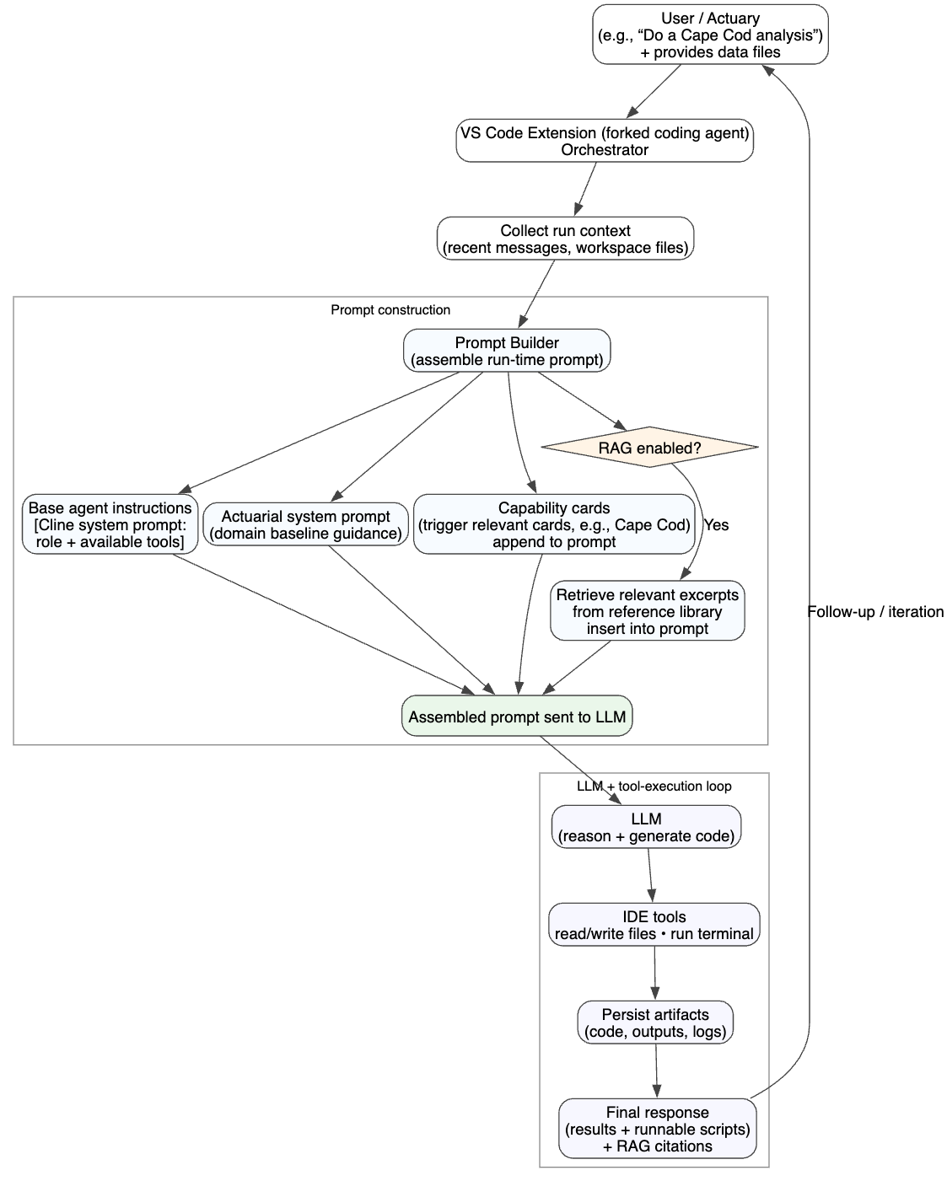
Actuarial system prompt (baseline guidance). The system prompt adds expectations about how work should be performed and reported. In particular, for tasks involving triangles, development, IBNR, Bornhuetter–Ferguson, Cape Cod, or related reserving/pricing calculations, it directs the agent to use the chainladder-python (Chainladder-Python contributors, 2026) Python package and to represent triangles using chainladder-python Triangle objects rather than re-implementing data manipulation and development mechanics from scratch. The prompt also requires a simple “Compliance” line in actuarial responses indicating whether chainladder-python was used (or whether execution was blocked due to missing dependencies). Beyond these coding guidelines, it emphasizes inspection of provided files (headers, column names, and existing scripts) before writing code, since small data-shape assumptions were observed as a common source of errors in tests (e.g. assuming monthly development or column/row-name conventions). The full actuarial system prompt text is reproduced in Appendix F.

Capability cards (method guides). Capability cards are short, method-specific instruction blocks stored in a small registry and injected at run time when the conversation context suggests a particular actuarial method. The cards are designed around observed failure modes in our unit and integration tests. Each card has a title, a content block, triggers that determine when it becomes active, and various commonly observed errors. Triggers are lightweight (keyword lists and simple regular expressions) so that activation is deterministic, making it easier to debug the tool (e.g. we can identify exactly what keyword prompted a particular card to be injected). The following sections discuss capability cards in detail.
(1) Card design. A key design decision was to keep cards targeted and concise rather than including a broad knowledge base in each card. This constraint was especially important because our agent is built on a fork of Cline and therefore inherits an extensive, software engineering-oriented system prompt that enables code execution and file/tool access (e.g., creating, reading, and editing project files). We rely on those capabilities and cannot materially shorten the baseline prompt. As a result, overly long or overly broad cards add further system prompt bloat and can exacerbate context drift by weakening the emphasis on the specific workflow constraints the model must follow to solve test-suite problems correctly. We therefore aimed for cards that encode only the minimum domain-specific guidance needed to reliably execute a method end-to-end and to address common failure modes, while avoiding redundant background material.
The card body is written as an implementation specification and can impose hard constraints such as the exact Python modules/APIs to use and key formulas. Each card is written to be directly actionable for implementation and debugging and typically includes:
- a step-by-step procedure (including decision points and ordering),
- expected inputs and outputs (required data shapes and bases),
- required Python modules and APIs when relevant (e.g., specific chainladder-python classes),
- formulas written in implementable form,
- sample code patterns or templates,
- common mistakes to avoid and known edge cases, and
- a quick verification checklist (what to print/check before moving on).

Exhibit 2.2.1: Example capability card (excerpt)
Below is an excerpt from one of our ratemaking capability cards. The full card also includes a complete code template and common error patterns. We show only the outline of the card here to illustrate how guidance is structured. Appendix B details where to find complete capability cards within the tool’s code repository.
- id: ratemaking-loss-ratio-indication
- title: Ratemaking: Loss Ratio Indication Method
- triggers (examples): keywords {“loss ratio method”, “loss ratio indication”, “loss ratio”}; regex matching variants of those keywords
- content excerpt:
Core formula
Indicated Rate Change = (Loss + LAE Ratio + Fixed Expense) / VPLR - 1

VPLR = 1 - Variable Expense - UW Profit
(VPLR contains ONLY variable expenses and profit, NOT fixed expenses)

Critical points (examples)
- Apply ULAE factor to the loss ratio before credibility weighting (if credibility is used)
- Fixed expense goes in the numerator (added to the loss ratio), not in VPLR
- VPLR contains only variable expenses and profit

Verification checklist
- ULAE applied to loss ratio before credibility weighting
- VPLR = 1 - variable_expense - profit (no fixed expense)
- Fixed expense added in numerator
- Formula is (loss_ratio + fixed_expense) / VPLR - 1
- Not using: loss_ratio / (1 - all_expenses) - 1

(2) Card detection and selection. For each API request to the LLM, we scan a short trailing window of the conversation (the most recent three messages, across user and assistant) and search for card triggers. Matching cards are scored using a recency-weighted algorithm (matches in the most recent message receive higher weight) and we select up to 10 cards, sorted by score, to limit prompt bloat and reduce conflicting guidance. We initially tested lower limits (e.g., 3 or 5 cards), but found that relevant cards would be excluded when multiple triggers were present. We therefore increased the cap to 10 to allow broader coverage while still limiting prompt growth.
(3) Integration into the system prompt. Aria rebuilds the full system prompt and conditionally appends a consolidated “Capability Cards” block at the end so they are last in the input. Card activation is re-evaluated each request per (2) above. Cards are therefore not injected permanently–a card that was active on an earlier turn will drop out automatically on later turns if its triggers are no longer present in the trailing window. Conversely, multiple cards can be active simultaneously if they are all triggered, in which case they are concatenated into the same block. The Capability Cards Block contains the items listed in Exhibit 2.2.2.

Exhibit 2.2.2: Capability card block
Guidance regarding the capability cards (e.g. strict adherence to the specified order of operations, exact module/function usage when specified, and formula precision) and statement that card guidance overrides generic system instructions and default coding/tool-use conventions.
List of active cards titles and the signals that triggered each.
Content of active card #1
Content of active card #2
Etc.

The complete card registry contains 17 cards spanning core reserving and ratemaking methods (e.g., chain ladder, Bornhuetter-Ferguson, Cape Cod, frequency-severity methods, credibility, on-leveling and trending, and loss ratio/pure premium indications).
The capability card workflow is illustrated in Exhibit 2.2.3 below.

Exhibit 2.2.3: Capability card workflow
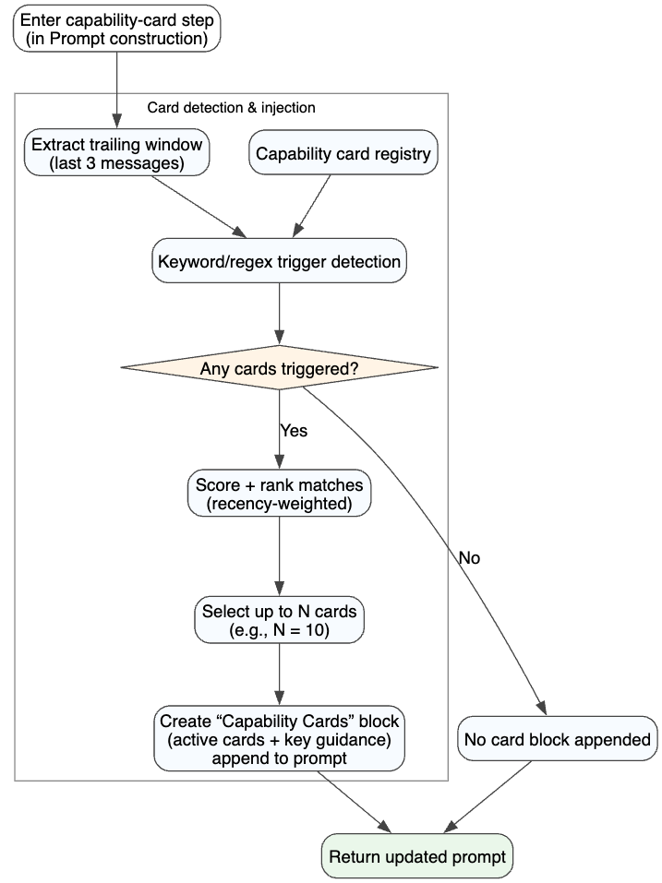
Document lookup (RAG) using source texts. In the RAG-enabled configuration, the agent is provided with short, relevant excerpts from actuarial source texts (Werner-Modlin and Friedland) during the run. The goal is to give the model quick access to definitions, formulas, and method notes available in the source material. Retrieval is designed to be lightweight, auditable, and non-blocking: if retrieval fails or returns no good matches, the system continues without adding RAG context. An example is shown below.

Exhibit 2.2.4: Example of RAG Invocation
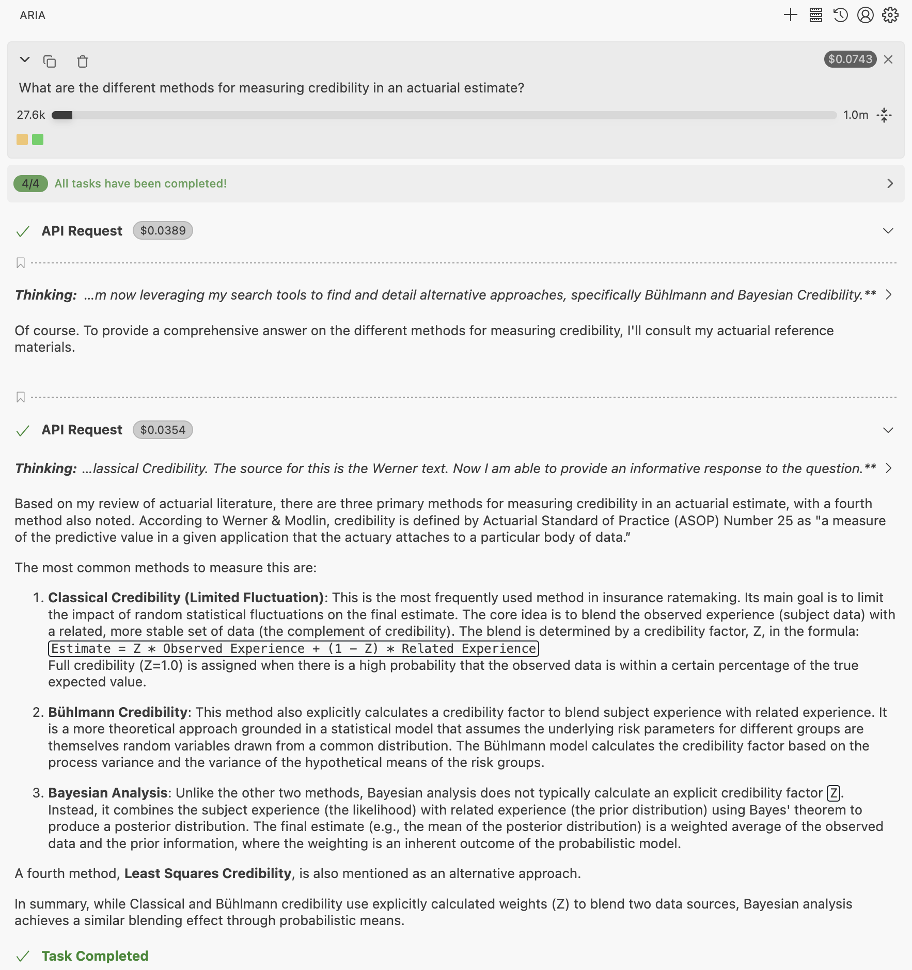

In the example above, the tool identifies the need to query actuarial textbooks for credibility methods. Excerpts from the Werner and Modlin textbook are provided to the LLM, which summarizes them and returns the information to the user.
(1) Index design. We use a parent-child chunk hierarchy to balance precision and context. The index is pre-built and stored as a single JSON artifact (actuarial-index.json) that is loaded when the VS Code extension activates. That is, the index is built during development and shipped as part of the VS Code extension. It contains:
- Child chunks (~400 characters): smaller snippets with pre-computed embeddings used for semantic matching. Those are the snippets that the vector search is performed against during retrieval. They are smaller so that the search can be more precise. Child chunks are not passed to the model.
- Parent chunks (~2000 characters): larger context blocks that are returned to the model.
Each child chunk links to a parent via a parent_id. The parent chunks of the child chunks that have the highest vector similarity with the query are injected in the prompt. Injecting larger chunks allows the model to have context of the portion of the actuarial textbook that is relevant to the query.

(2) Triggers for retrieval. RAG is expensive, both in terms of query latency and API credits. Therefore, it is only triggered when it is likely to be useful. It can be triggered in two different ways.
- For each run, the system extracts the latest user message and searches for actuarial keywords using regular expressions (“chainladder”, “credibility”, etc.). If one of those keywords appears in the user message, RAG is performed. This avoids consuming time and tokens with unnecessary API calls on non-actuarial queries.
- RAG is also available to the LLM as a tool. In our system prompt, the LLM is instructed on how it can voluntarily trigger RAG if it thinks an actuarial textbook could help it solve a problem. For example, that allows the LLM to look up definitions or formulas mid-solution. Both the automatic and tool-based paths use the same underlying index and search logic, with different defaults (see subsection (3) below).

Retrieval requires the RAG feature to be enabled via user settings. Disabling this setting disables both triggers for retrieval. The query embedding is computed at runtime and the system requires an embedding API key. If the embedding API key is missing, retrieval is skipped.
(3) Semantic search and ranking. If the above checks pass, the system embeds the query using the same embedding model that was used to build the index (Gemini gemini-embedding-001). It then computes cosine similarity between the query embedding and all child chunk embeddings, retains only matches above a similarity threshold, and maps those children back to their parent chunks. Because multiple child chunks can point to the same parent, results are deduplicated by parent (keeping the best child score per parent) and ranked by similarity. We return the top-K parent chunks (default K=3 when injecting into the system prompt; K=5 when called as a tool). Similarity thresholds are slightly stricter for system-prompt injection (default minScore=0.6) than for tool calls (default minScore=0.5).
(4) Prompt injection. Retrieved excerpts are injected as a dedicated system prompt component during prompt construction. The RAG block is inserted into a reserved placeholder section and formatted with:
- a header (e.g., “ACTUARIAL REFERENCE CONTEXT”),
- up to K results, each labeled with source name and page number (for citations), followed by the full parent chunk text, and
- a short footer reminding the model to treat the excerpts as reference context (not as a mandate to copy verbatim) and to prefer correct formula usage and definitions when they are directly relevant.

Reviewability and evaluation controls. Because the goal is a reviewable workflow, the agent is expected to (i) persist code and intermediate artifacts in the workspace, (ii) run code to validate intermediate results, and (iii) leave behind a final script that can be rerun. In addition, we restrict access to test-suite solutions during evaluation to prevent leakage and to ensure the agent can derive results from the case materials and allowed resources.
How these pieces map to evaluation configurations. Exhibit 2.2.5 summarizes the four configurations we evaluate: out-of-the-box (no actuarial guidance), system prompt only, capability cards without RAG, and capability cards with RAG.

Exhibit 2.2.5: Evaluation configurations
Configuration | What the agent receives at run time
Out-of-the-box (default) | Default agent instructions and tool access
System prompt only | Actuarial system prompt (chainladder-python guidance with required compliance line, instructions on file reading)
Capability cards (no RAG) | System prompt + relevant capability cards
Capability cards + RAG | System prompt + capability cards + retrieved excerpts from source texts

Other approaches considered. We also considered several alternative approaches—including MCP tool-wrapping, RPA-style automation, multi-agent architectures, and fine-tuning—but did not pursue them for this study. These alternatives and the reasoning behind each decision are discussed in Section 4.3.

2.3 Evaluation Design: Integration and Unit Tests
To assess whether an AI-assisted actuarial workflow is reliable–i.e., it produces the correct numbers under explicit assumptions, with code that can be inspected and rerun–we evaluate performance on a structured test suite built from fully worked case studies. The evaluation target is the ability to (i) ingest standard actuarial inputs, (ii) follow the specified method and assumptions, (iii) implement the calculations in code, and (iv) return numerically correct outputs. We used that test suite throughout development to measure the impact and value of different features. The unit and integration tests were derived from the worked case studies in the actuarial texts. These sources provide datasets, step-by-step procedures, and benchmark outputs suitable for automated scoring. For the tests, we used a spreadsheet translation of the PDF exhibits and made adjustments to the verbatim text examples to increase coverage of methods (e.g. modify to use an all-years’ weighted average loss development factor (LDF) instead of 3-year simple-average).

Test coverage: Reserving (Friedland). For reserving, we used Friedland, 2010 as the primary reference and targeted four common reserving approaches: Chain Ladder, Bornhuetter-Ferguson, and Cape Cod, along with three frequency-severity variants. This included any required intermediate logic such as loss development factor calculation and application of user-provided assumptions such as tail factor, tort reform adjustments and/or trend rates. We used the following XYZ Insurer exhibits from the Friedland, 2010 text: Chapter 7 - Exhibit II, Chapter 9 - Exhibit II, Chapter 10 - Exhibit II, and Chapter 11 - Exhibits I-IV.

Test coverage: Ratemaking (Werner-Modlin). For ratemaking, we used Werner-Modlin, 2016 and targeted the two indication frameworks covered on Exam 5: loss ratio and pure premium indications. This includes the supporting steps within those methods, such as on-leveling (using user-provided rate level factors), premium/loss trending, credibility calculations, and incorporation of other user-provided pricing inputs (e.g. ALAE/ULAE, profit, CAT load). We used the indication examples in Appendices A and B of the Werner-Modlin, 2016 text.
Testing Architecture. Each workflow is evaluated using both (a) an end-to-end integration test and (b) a set of decomposed unit tests. Integration tests represent complete case studies: the tool is provided with source data files and explicit assumptions and is asked to complete the full analysis, producing the specified final outputs. Unit tests break those same case studies into smaller, sequential steps, where each prompt provides the data, assumptions, and the correct code up to that point, and asks the tool to implement the next step. This design isolates where failures occur–whether the model struggles primarily with individual actuarial calculations, or with end-to-end analysis. The test-suite is stored in a separate repository from the main agent.

For automated scoring, we did not allow the assistant to ask clarifying questions during evaluation. The agent was required to proceed using only the information provided in the prompt and workspace; ambiguities that would normally be resolved via user confirmation were therefore treated as part of the task and could result in a test failure.

Exhibit 2.3.1 provides a concrete example using the Cape Cod workflow, showing the end-to-end integration test and its unit-test decomposition. The exhibit is presented at the level of inputs, tasks, and output formats (rather than full prompt text) to illustrate what is held fixed versus what is being evaluated at each step. Unless otherwise stated, numeric outputs are scored against ground truth using a 1% relative tolerance; for factor adjustments (e.g., tort reform or on-level factors), we instead apply an absolute tolerance of 0.001.

Exhibit 2.3.1: Integration vs. Unit Test
Evaluation item | Provided to the tool | Task | Required output format | What this isolates
Integration test: “Complete Cape Cod Method Analysis” | Data files: loss triangle, earned premium, past rate changes, and claim ratios.  Assumptions: latest-2 volume-weighted LDFs; 1.05 tail factor from age 132; 3.425% premium trend; tort reform adjustments effective 1/1/2006 (−10.7% in AY 2006; −33% in AY 2007+). | Complete the full Cape Cod analysis end-to-end under the stated assumptions. | Store final results in: total_cc_ultimate (total Cape Cod ultimate claims) and total_cc_ibnr (total Cape Cod IBNR reserves). | End-to-end execution: correct sequencing, consistent use of assumptions, data handling and intermediate artifact persistence.
Unit test Step 1: Current level earned premium | Earned premium + rate changes data. | Calculate current level earned premium. | current_level_earned_premium (pandas Series/array). | On-leveling mechanics and correct handling of rate change data in isolation.
Unit test Step 2: Tort reform on-level factors | Tort reform description + correct code up to Step 1. | Calculate factors to adjust all years to AY 2008 tort law level. | tort_reform_factors (pandas Series/array). | Tort reform adjustment logic and correct handling of tort reform data in isolation.
Unit test Step 3: Adjust reported claims | Triangle/claims data + correct code up to Step 2. | Adjust latest reported claims for tort reform to AY 2008 level. | adjusted_reported_claims (pandas Series/array). | Correct application of tort reform factors to reported claims (units, alignment by AY).
Unit test Step 4: Cape Cod ultimate claims | Tort-reform-adjusted triangle + on-level premium + LDF/tail/trend assumptions + correct code up to Step 3. | Calculate Cape Cod ultimate claims using the adjusted inputs, then adjust results back to original tort law level. | total_cc_ultimate | Correct Cape Cod implementation given correct prior artifacts; checks both development to ultimate calculation and and “adjust back” logic.
Unit test Step 5: Cape Cod IBNR | Prior artifacts + correct code up to Step 4. | Calculate IBNR. | total_cc_ibnr | Final reserve calculation.

Prompt and input encoding. To support consistent measurement, test prompts are standardized across methods: each test provides (i) a clear task statement, (ii) required assumptions and selections, (iii) data artifacts (tables/CSV files), and (iv) explicit output formats (the variable names and, where applicable, expected shapes/units). This “data + assumptions + output format” structure reduces ambiguity while still requiring valid actuarial calculations: the tool must implement the method correctly and produce auditable intermediate and final results in code.

Reference solutions and scoring. For each test, we first computed ground-truth targets in a spreadsheet implementation of the source case study (where the final result reconciles to the source text under the same assumptions) and then translated the calculations into a reference Python implementation, verifying that the Python outputs reconcile to the spreadsheet results. Scoring focuses on correctness of the final required outputs for integration tests and correctness of each step output for unit tests. Tests are evaluated as pass/fail based on numeric agreement within tolerance. We also assess structural validity such as presence of all required outputs in a reasonable format (returning a single value in a dataframe instead of a scalar would not be a reasonable format, for example). If the agent submits code that fails with a syntax error as its final response, the test case is scored as a failure.

3. Results
This section presents the empirical evaluation of the actuarial AI assistant across the four configurations defined in Exhibit 2.2.5. Under the best configuration, our analysis reveals a sharp contrast in performance: while the assistant is highly accurate when tasked with individual calculation steps, its reliability drops significantly when these same steps must be chained together into a full end-to-end workflow.
We first quantify this “reliability gap” and identify its primary drivers, specifically context drift and compound error probability (Section 3.1). We then discuss the impact of our interventions, comparing the effectiveness of each configuration. We illustrate these findings through case studies, showing how the assistant behaves on representative end-to-end actuarial workflows and demonstrating specific observed failure modes (Section 3.2). Unless otherwise noted, all results reported in Section 3 were generated using Claude Sonnet 4.5 as the underlying LLM.

3.1 Unit and Integration Tests
The unit tests and integration tests answer different questions about reliability. Unit tests measure whether the tool can execute the intermediary steps of an analysis correctly when the prior steps are correct. Integration tests measure whether the tool can complete an end-to-end analysis, which requires correct sequencing, keeping track of a larger context, and building upon multiple intermediate results. Exhibit 2.3.1 illustrated the distinction between integration and unit tests using the Cape Cod workflow as an example.

Across configurations, performance was consistently stronger on unit tests than on integration tests, indicating that isolated computational steps are generally more reliable than a full workflow. This gap is most pronounced in longer, multi-part workflows (e.g., complex frequency-severity methods and complete ratemaking indications) where correctness depends on multiple intermediate artifacts being computed, stored, and reused without drift. In contrast, shorter and more linear workflows (e.g., a single loss development method with straightforward inputs and outputs) tended to show smaller or no degradation when moving from unit to integration settings.

We consistently observed three patterns that contributed to the gap between unit and integration test performance:
- Workflow sequencing errors. The tool may apply the correct formulas but in the wrong order. For example, in frequency-severity severity development, it may develop claims and counts to ultimate separately and then divide ultimate claims by ultimate counts, rather than compute severity first (claims over counts) and then develop to ultimate.
- Guidance adherence breaks down on longer problems. When the analysis becomes complex and long, the tool stops consistently following the step-by-step guidance in the capability cards and instead applies formulas inconsistently or falls back to generic shortcuts.
- Input interpretation errors. The analysis can misread what the data fields mean or how the table is structured. Examples include mishandling nonstandard accident ages or interpreting evaluation dates incorrectly, leading to results that are materially off even if the arithmetic is otherwise consistent with actuarial literature.
Overall, the results suggest the main reliability gap is not individual calculations but end-to-end orchestration: keeping the correct sequence, retaining intermediate results consistently, and interpreting inputs (including system prompt and capability card instructions) correctly across the full workflow.

In the remainder of the Results section, we quantify these differences using overall pass rates by configuration, consistency across repeated runs, and we use case studies to illustrate common failure modes and demonstrate where and why integration tests diverge.

Exhibit 3.1.1: Unit and integration pass rates by configuration
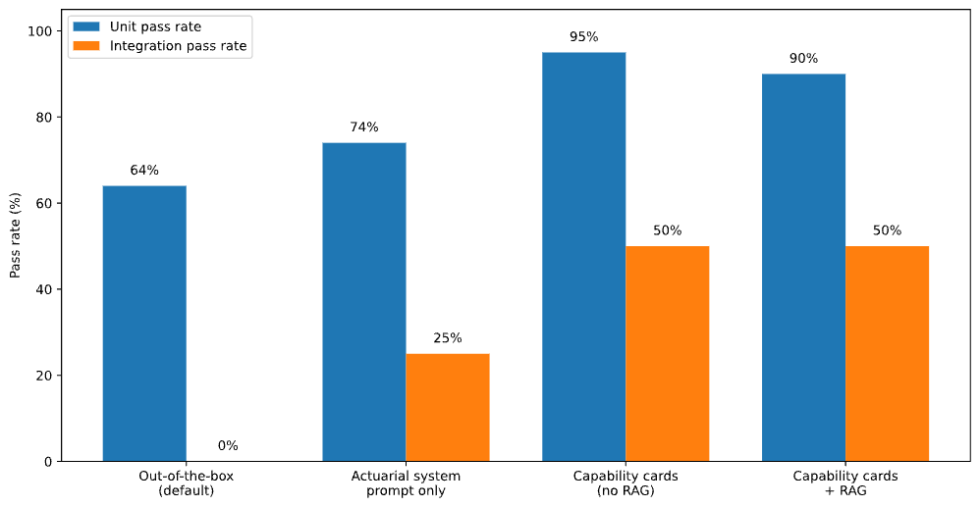
Configuration (Exhibit 2.2.5) | Unit pass rate | Integration pass rate
Out-of-the-box (default) | 64% (39/61) | 0% (0/8)
Actuarial system prompt only | 74% (45/61) | 25% (2/8)
Capability cards (no RAG) | 95% (58/61) | 50% (4/8)
Capability cards + RAG | 90% (55/61) | 50% (4/8)

Exhibit 3.1.1 shows that standardizing the agent’s workflow via the system prompt improves both unit and integration performance, but the largest gains come from the addition of capability cards. However, even the best configuration remains far from perfect on end-to-end workflows (50% pass rate). The three failure patterns described above—sequencing errors, guidance drift, and input misinterpretation—are driven primarily by two underlying factors: compound error probability and context drift.

First, integration tests face the cumulative probability of failure. Unlike a human analyst who may spot and correct a mid-analysis error, the current agentic workflow often propagates the error forward, causing the final result to fail the integration test despite correctly executing the majority of the individual steps. End-to-end ratemaking or reserving case studies in our test suite requires correctly chaining up to 14 distinct steps. Even with a high unit-level reliability (e.g., 95% per step), the probability of completing a 14-step chain without a single error drops significantly ($95\%^{14}=49\%$ assuming independence). Most of the integration tests have fewer than 14 steps however, so this is not the only driver.

Context drift compounds these errors as the workflow lengthens. In a full integration test, the context window (defined in Footnote 2) grows to include the system prompt, capability cards, RAG excerpts, conversation history, file reads, and code output. Prior work shows that LLM performance often degrades as prompts grow longer and relevant constraints become harder to reliably follow—the “lost in the middle” effect (Liu et al., 2023; Bai et al., 2023). Agentic tasks that require sustained multi-step execution over large contexts remain challenging, with failures frequently tied to instruction-following breakdown over long horizons (Liu et al., 2023; Jimenez et al., 2023). This explains the guidance adherence pattern noted above: as context grows, specific constraints such as the order of operations defined in a capability card are increasingly likely to be overlooked.

The tests also demonstrate the counterintuitive result that adding RAG worsens the unit test score and does not improve the integration test score. The reasons for this finding are discussed in Case Study 3 below.

Because the system is non-deterministic, the same configuration can produce materially different test outcomes across repeated runs, as demonstrated in case studies in Section 3.2 below. Exhibit 3.1.2 below quantifies run-to-run stability on integration tests for the Capability Cards + RAG configuration. Across five independent runs of the same 8 integration tests, the overall pass rate varied from 38% (3/8) to 63% (5/8), with an average of 50% (4/8).

Exhibit 3.1.2: Consistency of integration test results
Trial | Integration pass rate
1 | 63% (5/8)
2 | 38% (3/8)
3 | 63% (5/8)
4 | 38% (3/8)
5 | 50% (4/8)

3.2 Effect of System Prompt, Capability Cards and RAG: Case Studies
This section uses examples observed during testing to illustrate why performance differs across configurations in Exhibit 3.1.1. Each case study holds the actuarial task (integration test) constant and changes only the tool configuration, as defined in Section 2.3. We start with an example where the standard frequency-severity method’s integration test fails out-of-the-box but passes under the actuarial system prompt configuration.

Case Study 1: Standard Frequency-Severity Method
(out-of-the-box fails; actuarial system prompt passes)

Task. The integration test asks the agent to calculate total ultimate claims and total IBNR using the frequency-severity method where frequency and severity are developed separately. Closed-with-pay and reported claim counts should be developed to ultimate using a latest-4 volume-weighted average with 1.00 tail factor, and the average of the two count ultimates should be used as the ultimate frequency. Severity is defined as claims÷counts and should be developed using a latest-5 simple average with 1.01 tail factor. The required outputs are total_ultimate and total_ibnr.

Out-of-the-box outcome (fails). The out-of-the-box run fails the integration test materially:
- Expected total ultimate: 689.6M; produced 835.7M
- Expected total IBNR: 240.0M; produced 386.1M

The error was due to an implementation error when creating the severity triangle. The out-of-the-box solution divided the entire reported claims triangle by a single scalar per accident year (the latest count), rather than dividing claims by counts cell-by-cell at the same development age. Despite correct subsequent operations, the erroneous historical severities led to incorrect severity development factors and inflated ultimates.

System prompt outcome (passes). As discussed in Section 2.2, the system prompt configuration provides guidance to the AI tool to enforce chainladder-python usage to standardize data manipulation and calculation logic, guides the tool to review data input formats before generating code, and instructs it to run and debug its code to prevent syntax errors in the final output. Under the system prompt configuration, the agent constructs triangles as chainladder Triangle objects and performs triangle operations using the library’s native behavior. In this case, severity is computed with an element-wise triangle division (claims divided by counts at each cell), avoiding the critical bug in the previous section and resulting in final estimates that reconcile to the expected total ultimate and IBNR.

Takeaway. This case study highlights a common integration test failure mode: even when the agent’s high-level plan is reasonable, data-shape, alignment, or calculation mistakes (here, severity defined using the wrong denominator across development ages) can skew the final answer. The system prompt helps in this example because it pushes the agent toward consistent triangle operations and actuarial conventions.

Case Study 2: Werner Modlin Appendix A Loss Ratio Indication
(out-of-the-box fails, system prompt fails; capability card passes)

Task. This integration test asks the agent to complete a full loss ratio rate indication (Werner-Modlin Appendix A) using the provided data files and assumptions, and return the credibility-weighted indicated rate change. The prompt specifies: premium trending via an 8-point exponential trend fit on rolling 4-quarter average written premium per exposure, loss development via chain ladder method with specified averaging rules and a tail factor at age 63, loss trending for frequency and severity separately with specified 8-point (current) and 4-point (projected) exponential trends, expense/profit provisions, and credibility weighting using the trended present rates complement.

Out-of-the-box outcome (fails). The out-of-the-box run fails with a large error: expected rate indication of -0.94%, produced rate indication of +9.08%. The out-of-the-box failure came from two issues:
- Trend calculation returned factors instead of rates. The implementation treated exp(slope) (a factor) as the annual trend rather than converting the quarterly trend factor to a rate (exp(slope)-1) and then annualizing. That error propagates through premium, frequency, and severity trends.
- Trended present rates omitted net trend. The code applied only the “indicated vs taken” rate-change ratio and skipped the net trend component that accounts for loss and premium trend.

System prompt outcome (improved but still fails). Under the system prompt configuration, the final result is closer but still wrong: expected rate indication of -0.94%, produced rate indication of +2.98%. A new error occurred that did not appear under the out-of-the-box configuration:
- The two-step trend procedure was implemented incorrectly. Instead of calculating different factors for each calendar year and applying either the current/projected trend depending on the written/earned/valuation/forecast dates, the agent applied a single premium trend factor to total earned premium, a single loss trend factor to total ultimate losses, and simplified the trend period logic.

Here, the system prompt was insufficient because this workflow depends less on using chainladder correctly and more about reproducing specific worksheet logic. The system prompt pushes the agent toward reasonable defaults and library usage, but it does not spell out the loss ratio indication “recipe” in enough detail (especially trending mechanics). As a result, definitional slips–like mixing up trend rates vs. factors, trending an aggregate instead of by period, or omitting net trend in trended present rates complement–materially impact the final indicated rate change.

Capability card outcome (passes). In the capability card configuration, multiple ratemaking cards were injected (Loss Ratio Indication, Premium On-Leveling, Premium Trending, Loss Trending, and Trended Present Rates). Together, these cards function like a compact loss ratio indication playbook: they specify the required data sources, trend-fitting methods, Two-Step structure, and the complement formulas used in the Werner-Modlin source text. That directly addresses the three bugs that occurred in the out-of-the-box and system prompt configurations:
- Trend “rate vs factor” errors. The Premium Trending and Loss Trending cards explicitly require LOGEST-style regression (linear regression on log values) and define the trend rate as exp(slope)−1, with quarterly-to-annual compounding (1+q)^4−1. They also call out common substitutes (geometric mean of changes) and warn against fitting trends on the wrong series.
- Missing net trend in trended present rates. The Trended Present Rates card gives the exact formula TPR=(1+net_trend)^t×(1+prior_indicated)/(1+prior_implemented)−1 and defines net_trend=(1+loss_trend)/(1+premium_trend)−1, explicitly warning against leaving out the net trend term.
- Two-step trend. The Premium Trending and Loss Trending cards’ Two-Step requirements reduce another frequent source of drift in long workflows: applying a single trend factor to aggregate premium or losses instead of trending by period (calendar year for premium, accident year for losses).

Separately, the Loss Ratio Indication card reinforces the correct placement of fixed vs. variable expenses and the requirement to apply the ULAE factor at the correct point in the workflow (before credibility weighting), reducing the chance of formula mistakes later in the calculation chain.

Takeaway. This case study highlights a different failure mode than Case Study 1. In this ratemaking example, the biggest risks were not triangle mechanics, but faithfully reproducing the source text’s multi-step structure–especially trend fitting/annualization, Two-Step trending, and adjusting complements of credibility. The capability cards help because they encode those mechanics explicitly (including sample code, common mistakes and checklists), which is difficult to achieve with a single global system prompt without substantially increasing the context size.

Case Study 3: Werner-Modlin Appendix B Pure Premium Indication
(all configurations fail)

Task. This integration test asks the agent to complete a full pure premium rate indication (from Werner-Modlin Appendix B) using the provided data files and assumptions, and store the final result in total_indicated_pure_premium. The prompt specifies: develop state reported loss and allocated loss and adjustment expenses (ALAE) using countrywide LDFs from the chain ladder method (all-years simple average, 1.01 tail factor at age 63); estimate loss trend from the regional quarterly pure premium series (8-point exponential for current, 4-point exponential for projected); apply a ULAE factor of 1.012; apply credibility using 5-year claims (683) and full credibility claims (1082) with a regional non-CAT complement pure premium of $585.75; then add per-exposure loadings (CAT $103.85, reinsurance $15.68, fixed expense $77.74) and apply variable expense (13.8%) and profit/contingency (5%). Rates are assumed effective 1/1/2017 for 12 months (policy term 12 months; rates in effect 12 months).

Capability card outcome (fails). Under the capability card configuration, the test fails: expected pure premium indication of 915.32, produced pure premium indication of 910.28 (0.6% low). Two issues drove the miscalculation:
- Wrong valuation date for state data. The agent treated the state experience as valued at year end 2016 instead of year end 2015, making the accident years appear one year more mature than intended. That pushes the selected CDFs lower and produces lower ultimates. The prompt did not explicitly specify the valuation date, but it was intended to be inferred from the loss triangle.
- ULAE applied at the wrong step. The agent applied the ULAE factor after credibility weighting, which applies ULAE to both the subject experience and the regional complement. In this example, the regional complement is meant to be assumed to already include ULAE. We also tested adding an explicit capability-card rule to apply ULAE before credibility weighting unless the user says otherwise, but this run still applied ULAE at the end of the workflow.
Both issues are subtle. In practice, the valuation date can be ambiguous (e.g., a year-end 2016 evaluation may use year-end 2015 experience for operational reasons), and complements are not always labeled consistently as including or excluding ULAE. In a real workflow, a reasonable agent response might be to ask one clarifying question (“Confirm valuation date?”, or “Does the complement include ULAE?”) before calculating. For the purpose of running automated evaluations, we do not allow the assistant to ask clarifying questions, so these relatively small conventions can result in test failure.

This case also illustrates a form of context drift induced by our capability-card design. As detailed in Section 2.2.2, on each LLM API request we re-evaluate whether to inject a card by scanning only a short window (the last three user/assistant messages) for keyword/regex triggers, and we rebuild the system prompt each time rather than persisting prior injections. As a result, if the triggering terms are no longer present in that trailing window, the relevant card is not re-injected on subsequent turns. By the time the agent is assembling the final indicated pure premium, the card’s step order and constraints may therefore be absent from the current system prompt and only available indirectly through the longer conversation history. This design reflects a tradeoff between persistent procedural guidance and keeping the context compact.

Capability card + RAG outcome (fails). Adding RAG did not improve the result. The run still fails, with the same issues driving the test failure. This pattern is consistent with our overall evaluation results, where enabling RAG slightly reduced unit test pass rates and produced no improvement in integration test pass rates. In principle, retrieval could help by surfacing a definition, formula, or step order directly from the source material. In practice, three limitations show up in this case study:
- RAG does not resolve missing conventions in the prompt. The two drivers of failure (valuation date and whether the regional complement includes ULAE) are not explicit rules in the source material. Even if retrieval returns the relevant method description, the agent still has to decide which convention applies to this dataset.
- PDF exhibits do not reliably translate into the kind of text the agent can use. Our RAG implementation injects retrieved snippets as plain text. When the relevant content is embedded in an exhibit–tables, multi-level headers, footnotes, or mathematical formulas–the conversion often loses layout, reading order, and alignment (e.g., which values belong to which row/column, or which definition a footnote qualifies). This can turn a precise exhibit into ambiguous prose or a “scrambled” table, making the retrieved content hard to interpret. Improving faithful extraction of layout, tables, and math from PDFs is an active area of document intelligence research, including layout-aware and multimodal approaches designed specifically to preserve structure (Blecher et al., 2023; Huang et al., 2022).
- Retrieval increases context load and can dilute key instructions. For long, multi-step methods, adding several retrieved chunks increases the amount of text in the agent’s context. Even when the retrieved material is relevant, the extra context can make it easier to miss or forget a specific instruction that matters at the step where the error occurs. This is consistent with evidence that models use long contexts unevenly (often under-weighting information placed mid-context) and that irrelevant or weakly relevant retrieved passages can distract and degrade accuracy in RAG settings (Liu et al., 2024; Amiraz et al., 2025; Yoran et al., 2023).

These failure modes likely reflect our particular RAG implementation, rather than an inherent limitation of RAG itself. More complex or specialized retrieval designs (discussed in Section 4.3) may help mitigate some of the issues observed here, although we do not evaluate those alternatives in this study.

Takeaway. This case study shows the limits of adding more guidance when errors come from unstated conventions and long workflow execution. Even with capability cards, minor assumptions can drive a test failure when clarifying questions are disallowed. It also demonstrates how context drift can matter in practice: rules introduced in earlier steps can be deprioritized later under a recency-based injection scheme. Adding RAG did not address either problem, and in this example it added additional text that was difficult to use (exhibit/table formatting) and increased the amount of context competing for attention.

3.3 Capability Card Design and Reliability
Finally, we discuss some limitations of the capability card design (specificity, overlap, and triggering behavior) and how they affect reliability in longer workflows.
Specificity helps, but can “overfit.” The strongest gains from capability cards come when the card is specific enough to function as a step-by-step recipe: it names the required inputs and outputs, fixes the order of operations, and includes implementable formulas or code patterns. Case Study 2 illustrates this effect: the ratemaking cards specify details that are subtle and easy to get wrong in code (e.g., how the exponential trend is fit and annualized, how Two-Step trending is applied, and the formula for trended present rates). There is a tradeoff: as cards become more detailed, they can start to encode assumptions that are true for one worked example, but not for a slightly different data layout or a different version of the same method. Overly specific cards behave like model overfitting: they perform very well on the “training example” patterns they were written against, but they generalize less reliably when the same concept appears in a different form.
Overlap can create conflicting guidance. As the card library expands, related concepts inevitably appear in multiple places. For example, two-step trending can apply to both losses and premium, but the prospective trend period is anchored differently: losses are trended from the current date to the average future accident date, while premium is trended from the current date to the average future written date. These dates can differ, and in a long context this distinction can be easy to miss. When multiple cards trigger in the same run, the agent may merge pieces of guidance across cards or apply the right logic in the wrong place. The agent can follow each individual card, but still produce an incorrect overall workflow because it has combined instructions that were meant to be used in different contexts.
Triggering and ordering considerations in long runs. On each API request, our card system scans a short trailing window of recent user/assistant messages (the most recent three) for keyword/regex triggers and ranks matching cards with a recency-weighted score. The selected cards are appended as a single block at the end of the system prompt, but a previously relevant card can also drop out entirely on later turns if its trigger terms are no longer present in the trailing window. This design makes guidance easier to use earlier in the workflow, but long, multi-step methods accumulate substantial context. As the run progresses, key instructions may be diluted by competing context or disappear from the system prompt altogether, increasing the chance that late steps revert to defaults or apply a convention inconsistently. Case Study 3 reflects this dynamic: even when guidance is provided correctly at the start, it may not be applied consistently by the final calculation.
Capability cards materially improve performance on many standardized tasks by encoding useful slices of actuarial knowledge–repeatable procedures, common pitfalls, and formulas. However, the above discussion and case studies highlight a limit of this approach: actuarial work often relies on deeper, context-dependent expertise that is not always explicit in a prompt or a textbook excerpt. As workflows get longer and more interconnected, that deeper layer becomes harder to reproduce by injecting increasingly detailed “cheat sheets” into a general-purpose model.

4. Discussion and Conclusion
This section interprets the empirical findings in Section 3 and translates them into practical guidance for actuarial use. We first discuss where the assistant is most useful in a human-in-the-loop workflow (Section 4.1), then summarize key limitations that bound how the results should be interpreted (Section 4.2), and finally outline opportunities for future research to improve reliability and extend the approach (Section 4.3), concluding with a brief summary of the main takeaways (Section 4.4).

4.1 Practical Implications
Our results suggest that today’s AI coding agents can add value in actuarial work, especially for well-specified, verifiable steps, but they are not yet reliable enough to run complex ratemaking or reserving workflows end-to-end without review. This is evidenced by our integration-test performance being significantly inferior to unit test performance and varied across repeated runs, reinforcing the need for actuarial oversight.
Use it as a copilot. In practice, the assistant is most useful when treated like a junior analyst who is fast at implementation, but dependent on clear instructions and careful review. It can draft code, build intermediate tables/triangles, and automate standard calculations–while the actuary retains responsibility for method selection, assumptions, review, and final sign-off.
Best-fit tasks and practical controls. The unit vs. integration gap observed in Section 3 suggests the assistant is most effective when work can be modularized and verified. Examples include:
- building triangles and manipulating loss runs or exposure data in code;
- implementing discrete steps such as on-leveling, trending, factor selection, and credibility calculations provided explicit assumptions; and
- generating first-pass scripts plus reconciliation checks that an actuary can validate and refine.

To reduce failure risk on longer workflows, users should:
- make conventions explicit (e.g., valuation date, complement definitions such as whether ULAE is included, tail/LDF selection rules);
- introduce checkpoints and reconcile intermediate results (e.g., selected LDFs, trended premiums/losses, developed ultimates) before proceeding; and
- review artifacts directly, including code diffs and saved intermediate tables.

Actuarial Standards of Practice (ASOPs). The tool can fit comfortably into actuarial professionalism guidance if it is treated as a source of draft work product that must be reviewed like any other analyst output. Several ASOPs provide relevant framing:
- ASOP No. 23 (Data Quality) (Actuarial Standards Board [ASB] 2016) emphasizes the actuary’s responsibility to evaluate whether data are appropriate for the intended use and to address material data limitations.
- ASOP No. 41 (Actuarial Communications) (ASB 2010) addresses what should be communicated about methods, assumptions, uncertainty, and reliance, which is useful when an analysis incorporates AI-generated work products.
- ASOP No. 56 (Modeling) (ASB 2019) is relevant when the assistant is used to build or modify models, including expectations around validation and reasonableness checks.

4.2 Limitations
This study and tool have several limitations that affect how broadly the results should be interpreted.
Scope. The tool and test suite are scoped to CAS Exam 5-level reserving and ratemaking methods, specifically to a subset of case studies from the Friedland and Werner-Modlin source texts. As a result, these results do not directly generalize broadly across lines of business, regulatory environments, or real production settings with large, messy datasets, inconsistent coding, missing fields, varying data level aggregations, or company-specific schemas and segmentation.
Test suite design constraints. Our scoring focuses on whether the tool produces specific required outputs within strict tolerances, which makes results easy to compare but can understate “near-miss” usefulness (e.g., runs that get most intermediate steps correct but fail due to one convention or small error). In addition, for automated testing we do not allow the assistant to ask clarifying questions; this is a disadvantage to workflows where conventions are ambiguous (e.g. as demonstrated in Case Studies 2 and 3 in Section 3.2) and would normally be resolved through a brief user confirmation.
Dependence on model, tool versions, and environment. Results reflect one specific LLM version and a particular version of VS Code/Cline. Because both model behavior and open-source agent frameworks change quickly, measured pass rates should be viewed as a point-in-time snapshot. Similarly, as discussed in Section 3.1, the non-deterministic nature of the system contributes to material run-to-run variation even under the same configuration.
Cost and operational considerations. Agentic workflows can be expensive because they generate long contexts (tool logs, code diffs, intermediate outputs) and require chaining together multiple tool calls and reasoning blocks. Unit tests cost about $10 per case study per run. The cost of running all unit tests is about $70. Running our entire test suite costs about $150. We did not treat runtime and API cost as primary optimization targets in this study, so cost-effectiveness will depend on the model/provider and on how workflows are structured in practice.

4.3 Opportunities
The results in Section 3 suggest a consistent pattern: the assistant can perform many individual steps, but end-to-end results are less reliable. The items below list practical directions for future research that could improve performance and usability:
- Add checkpoints to long workflows. Break long workflows into checkpoints. At each stage, the agent would print/save the intermediate result (e.g., selected LDFs, trended losses, ultimates) and run self-checks before continuing. This could include reconciling totals or confirming expected dimensions match. The checkpoint could also require a brief structured review (by a human or a checker agent, as discussed later in this section) of intermediate results. This approach aims to catch mistakes closer to where they occur, reducing the compounding errors observed in integration tests.
- Add domain-specific clarifying questions. Cline/Aria natively supports clarification which lets the assistant request missing required inputs or resolve ambiguity instead of assuming. We disabled this feature during evaluation to keep scoring fully automated, but in practice, clarification could prevent “wrong-assumption” errors. An extension would be to add actuarial-specific clarification guidance (informed by the case studies in Section 3.2) so the assistant prioritizes having clarity on a small set of conventions (e.g., experience/valuation dates, exposure basis, aggregation basis, on-leveling/trend choices, expense treatment). Prior research finds that targeted clarifying questions can materially improve performance on under-specified tasks, including code generation (Mu et al., 2024).
- Improve capability cards and conflict handling. One direction is to expand card scope and coverage over additional methods and concepts, and improve retrieval/ranking of relevant cards so the most relevant guidance is injected consistently. A second direction is to reduce overlap between cards and/or add explicit precedence rules (global rules vs. method-specific rules) to prevent conflicting instructions. Finally, an open design question is how to improve the “trailing-window” behavior without materially increasing prompt bloat. One possible approach is to retain only a compact subset of high-priority constraints from active cards across subsequent turns–even if trigger keywords drop out–while letting full card text appear only when it is needed.
- Improve RAG for actuarial source texts. Section 3 suggests that plain-text retrieval can reduce reliability when key information lives in exhibits, so one direction is to make retrieval layout more structure-aware by extracting tables and equations into structured artifacts (e.g., markdown/JSON that preserves headers, footnotes, and reading order) and retrieving those artifacts rather than raw PDF text. A second, complementary direction is to improve how the system handles cases where relevant context is distributed across multiple sections (definitions, caveats, and formulas separated by pages). Instead of injecting several loosely related snippets, the pipeline could build higher-level summaries that consolidate material into a shorter, more actionable form. Recent work on hierarchical indexing via recursive summarization (e.g., RAPTOR, Sarthi et al., 2024) provides one example of how summary-based retrieval can improve access to information in long documents. Methods that make retrieval more selective–retrieving only when helpful and critiquing whether retrieved passages are actually useful–may reduce distraction in long workflows (Asai et al., 2024).
- Context management. In this study we rely on Cline’s default truncation/summarization features (Section 2.2.1), but alternative context-management strategies may help reduce drift in longer workflows. One direction is to maintain an explicit, compact working-memory record (e.g., key assumptions, selections, and intermediate results) that is prioritized for retention while older conversational detail is offloaded and retrieved as needed, consistent with memory-tiered agent designs such as MemGPT (Packer et al., 2024). A second direction is targeted prompt compression–selectively compressing or rewriting verbose artifacts (e.g. long tool outputs, file reads, or retrieved excerpts) while preserving key information to remain in-context, rather than being replaced by a single coarse summary as in Cline’s native Auto Compact (Jiang et al., 2023).
- Explore fine-tuning when actuarial step-by-step data becomes available. Prompting and retrieval can steer a general-purpose model, but they may not fully solve issues with reliability on long or more complex workflows. If a high-quality, extensive dataset of actuarial problems with intermediate checkpoints (selections, assumptions, and saved artifacts) were available, fine-tuning could help the model internalize sequencing and actuarial logic. Adjacent-domain (finance) research shows that domain instruction tuning–either with large multi-task instruction datasets spanning diverse document types/modalities (PIXIU, Xie et al., 2023) or with smaller, carefully curated instruction sets drawn from domain sources (InvestLM, Yang et al., 2023)–can yield models that perform more reliably on domain-specific tasks.
- Alternative approaches not pursued in this study. Several alternative design approaches were considered but not pursued. Each may warrant exploration in future work.
  - MCP tool-wrapping. One option was to build a set of Model Context Protocol (MCP) tools that wrap chainladder-python functions for each actuarial method. We did not pursue this because it limits the range of capabilities to a fixed set, restricts users’ ability to customize calculations, and makes calculation logic difficult to review—conflicting with our goal of producing editable, rerunnable scripts rather than “black boxes.” A future direction could explore a hybrid approach in which MCP tools handle well-defined sub-steps (e.g., triangle construction) while the agent retains flexibility for the overall workflow.
  - RPA-style automation. Scripted, deterministic steps that move data through predefined spreadsheets or click through existing tools could automate specific workflows but cannot produce the reviewable, flexible Python code we target. In addition, RPA scripts are often non-robust to changes in file formats, workbook layouts, or interface updates.
  - Multi-agent architectures. We considered (i) a planner-executor-checker split, but given the kinds of failures we observed, we did not expect two broad roles to address the main issues. We also considered (ii) highly role-specialized agents aligned to individual steps (e.g., one agent for triangle construction, one for LDF calculation, etc.), but this introduces significant coordination overhead while still requiring reliable handoffs. A possible direction is structured execution loops that separate planning, execution, and verification without a full multi-agent system—for example, a “plan → act → check” loop (e.g., ReAct, Yao et al., 2023), where the agent commits to a checklist and required intermediate artifacts up front, then alternates between implementation and targeted checks before proceeding.

4.4 Conclusion
This study demonstrates that an IDE-native coding agent can be specialized for actuarial workflows, and that evaluation on worked actuarial textbook case studies provides a practical way to quantify reliability at both the step and workflow level. Empirically, capability cards were the most effective in our setting: they improved accuracy on many standardized tasks by encoding implementable formulas, ordering constraints, and verification checks. Our plain-text RAG approach did not yield additional gains and at times introduced ambiguity or distraction when key details lived in exhibits or were dispersed across the source text. The persistent gap between unit and integration performance highlights that the limiting factor is not isolated calculations but end-to-end orchestration under long and growing contexts. In practice, this supports using the assistant as a reviewable copilot–accelerating implementation and automating repeatable steps–while relying on actuarial oversight and intermediate validation to manage risk of errors.

References
Actuarial Standards Board. (2010). Actuarial Standard of Practice No. 41: Actuarial communications (Doc. No. 120; adopted December 2010; effective May 1, 2011). https://www.actuarialstandardsboard.org/wp-content/uploads/2014/02/asop041_120.pdf

Actuarial Standards Board. (2016). Actuarial Standard of Practice No. 23: Data quality (Doc. No. 185; adopted December 2016; effective April 30, 2017). https://www.actuarialstandardsboard.org/wp-content/uploads/2017/01/asop023_185.pdf

Actuarial Standards Board. (2019). Actuarial Standard of Practice No. 56: Modeling (Doc. No. 195; adopted December 2019; effective October 1, 2020). https://www.actuarialstandardsboard.org/wp-content/uploads/2020/01/asop056_195-1.pdf

Amiraz, C., Cuconasu, F., Filice, S., & Karnin, Z. (2025). The distracting effect: Understanding irrelevant passages in RAG. In Proceedings of the 63rd Annual Meeting of the Association for Computational Linguistics (Volume 1: Long Papers) (pp. 18228–18258). Association for Computational Linguistics. https://aclanthology.org/2025.acl-long.892/ (doi:10.18653/v1/2025.acl-long.892)

Anthropic. (2025, September 29). Introducing Claude Sonnet 4.5. Retrieved February 15, 2026, from https://www.anthropic.com/news/claude-sonnet-4-5

Anthropic. (n.d.). Model system cards. Retrieved February 15, 2026, from https://www.anthropic.com/system-cards

Anysphere, Inc. (2026). Cursor Terms of Service (last updated Jan 13, 2026). Retrieved February 15, 2026, from https://cursor.com/terms-of-service

Asai, A., Wu, Z., Wang, Y., Sil, A., & Hajishirzi, H. (2024). Self-RAG: Learning to retrieve, generate, and critique through self-reflection. International Conference on Learning Representations (ICLR 2024). https://openreview.net/forum?id=hSyW5go0v8 (also: https://arxiv.org/abs/2310.11511; doi:10.48550/arXiv.2310.11511)

Arena. (n.d.). Arena leaderboard (leaderboard overview). Retrieved February 15, 2026, from https://arena.ai/leaderboard

Blecher, L., Cucurull, G., Scialom, T., & Stojnic, R. (2023). Nougat: Neural optical understanding for academic documents. arXiv. https://arxiv.org/abs/2308.13418 (doi:10.48550/arXiv.2308.13418)

Chainladder-Python contributors. (2026). chainladder: Property and Casualty Loss Reserving in Python (Version >= 0.8.21) [Computer software]. Casualty Actuarial Society.

Cline Bot Inc. (2026). Cline (Version 3.66.0) [Computer software]. GitHub repository. Retrieved February 21, 2026, from https://github.com/cline/cline

continuedev/continue. (n.d.). Continue (GitHub repository). Retrieved February 15, 2026, from https://github.com/continuedev/continue

Friedland, J. F. (2010). Estimating unpaid claims using basic techniques (Third version, July 2010). Casualty Actuarial Society. https://www.casact.org/sites/default/files/2021-03/5_Friedland.pdf

Google AI for Developers. (n.d.). File Search | Gemini API. Retrieved February 15, 2026, from https://ai.google.dev/gemini-api/docs/file-search

Google Cloud. (n.d.). Gemini 2.5 Pro | Generative AI on Vertex AI. Retrieved February 15, 2026, from https://docs.cloud.google.com/vertex-ai/generative-ai/docs/models/gemini/2-5-pro

Harada, K., Yamazaki, Y., Taniguchi, M., Kojima, T., Iwasawa, Y., & Matsuo, Y. (2024). Curse of instructions: Large language models cannot follow multiple instructions at once. OpenReview (ICLR 2025 submission). Retrieved February 15, 2026, from https://openreview.net/forum?id=R6q67CDBCH

Huang, Y., Lv, T., Cui, L., Lu, Y., & Wei, F. (2022). LayoutLMv3: Pre-training for document AI with unified text and image masking. arXiv. https://arxiv.org/abs/2204.08387

Jiang, H., Wu, Q., Lin, C.-Y., Yang, Y., & Qiu, L. (2023). LLMLingua: Compressing Prompts for Accelerated Inference of Large Language Models. Proceedings of the 2023 Conference on Empirical Methods in Natural Language Processing, 13358–13376. https://aclanthology.org/2023.emnlp-main.825/ (doi:10.18653/v1/2023.emnlp-main.825)

Jimenez, C. E., Yang, J., Wettig, A., Yao, S., Pei, K., Press, O., & Narasimhan, K. R. (2024). SWE-bench: Can language models resolve real-world GitHub issues? In The Twelfth International Conference on Learning Representations (ICLR 2024). https://openreview.net/forum?id=VTF8yNQM66

Liu, N. F., Lin, K., Hewitt, J., Paranjape, A., Bevilacqua, M., Petroni, F., & Liang, P. (2024). Lost in the middle: How language models use long contexts. Transactions of the Association for Computational Linguistics, 12, 157–173. https://aclanthology.org/2024.tacl-1.9/ (doi:10.1162/tacl_a_00638)

Microsoft Visual Studio Marketplace. (n.d.). Cline (VS Code extension listing). Retrieved February 15, 2026, from https://marketplace.visualstudio.com/items?itemName=saoudrizwan.claude-dev

Microsoft Visual Studio Marketplace. (n.d.). Continue – open-source AI code agent (VS Code extension listing). Retrieved February 15, 2026, from https://marketplace.visualstudio.com/items?itemName=Continue.continue

Mu, F., Shi, L., Wang, S., Yu, Z., Zhang, B., Wang, C., Liu, S., & Wang, Q. (2024). ClarifyGPT: A framework for enhancing LLM-based code generation via requirements clarification. Proceedings of the ACM on Software Engineering, 1 (FSE), Article 103. https://doi.org/10.1145/3660810
Packer, C., Fang, V., Wooders, S., Lin, K., Patil, S. G., Stoica, I., & Gonzalez, J. E. (2024). MemGPT: Towards LLMs as Operating Systems. arXiv. https://arxiv.org/abs/2310.08560 (doi:10.48550/arXiv.2310.08560)
Sarthi, P., Abdullah, S., Tuli, A., Khanna, S., Goldie, A., & Manning, C. D. (2024). RAPTOR: Recursive abstractive processing for tree-organized retrieval. arXiv. https://arxiv.org/abs/2401.18059 (doi:10.48550/arXiv.2401.18059)
trypear/pearai-app. (n.d.). PearAI app (GitHub repository). Retrieved February 15, 2026, from https://github.com/trypear/pearai-app

voideditor/void. (n.d.). Void (GitHub repository). Retrieved February 15, 2026, from https://github.com/voideditor/void

Werner, G., & Modlin, C. (2016). Basic ratemaking (5th ed., May 2016). Casualty Actuarial Society. https://www.casact.org/sites/default/files/old/studynotes_werner_modlin_ratemaking.pdf

Xie, Q., Han, W., Zhang, X., Lai, Y., Peng, M., Lopez-Lira, A., & Huang, J. (2023). PIXIU: A large language model, instruction data and evaluation benchmark for finance. arXiv. https://arxiv.org/abs/2306.05443 (doi:10.48550/arXiv.2306.05443).

Yang, Y., Tang, Y., & Tam, K. Y. (2023). InvestLM: A large language model for investment using financial domain instruction tuning. arXiv. https://arxiv.org/abs/2309.13064 (doi:10.48550/arXiv.2309.13064).

Yao, S., Zhao, J., Yu, D., Du, N., Shafran, I., Narasimhan, K., & Cao, Y. (2023). ReAct: Synergizing reasoning and acting in language models. International Conference on Learning Representations (ICLR 2023). https://arxiv.org/abs/2210.03629 (doi:10.48550/arXiv.2210.03629).

Yoran, O., Wolfson, T., Ram, O., & Berant, J. (2023). Making retrieval-augmented language models robust to irrelevant context. arXiv. https://arxiv.org/abs/2310.01558

zed-industries/zed. (n.d.). Zed (GitHub repository). Retrieved February 15, 2026, from https://github.com/zed-industries/zed

Appendix A: VS Code Extension Installation (ARIA)

Prerequisites
- Visual Studio Code (desktop) with access to the Extensions view/Marketplace.
- An LLM endpoint (cloud or local). ARIA supports multiple providers (e.g. Anthropic, OpenAI, Google Gemini, Azure, etc.).

Install ARIA from the VS Code Marketplace
- Open Extensions in VS Code (View → Extensions, or or ⇧⌘X / Ctrl+Shift+X).
- Search by the extension identifier (most precise):
  - In the Extensions search bar, use: @id:hugolatendresse.aria-dev
- Select Aria (publisher: hugolatendresse) and click Install
- If prompted, trust the publisher to enable the extension.
- Reload VS Code if prompted (“Restart Extensions” / reload window).
- Once VS Code has reloaded, you should see a triangle icon in the left panel:
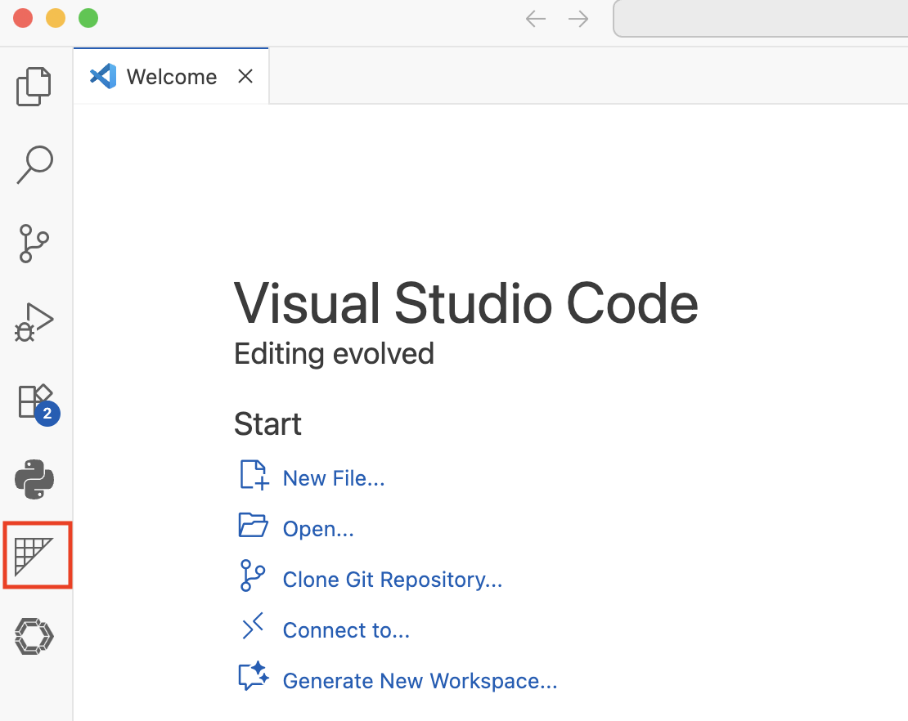
- Click the Settings button:
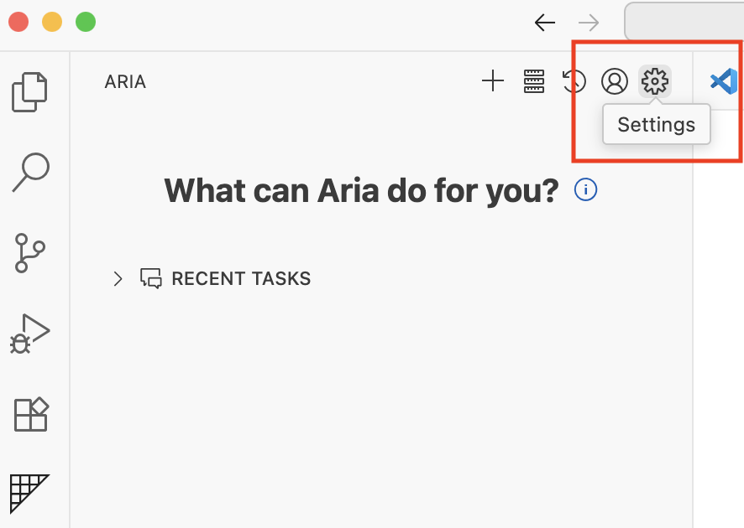
- You should see an API Configuration page. You can either sign up with Cline to use their list of available LLMs, or bring your own API key obtained from any LLM provider.
- Once your API key has been provided or you have authenticated through Cline, you may interact with Aria.

The default setting is that Aria asks for approval to execute any command. You may click the arrow on the right of "Safe Commands" below and enable auto-approve for certain commands at your own discretion.



Further detail on configuring API/model settings and providing ARIA access to read, write and edit files are included at the extension page: https://marketplace.visualstudio.com/items?itemName=hugolatendresse.aria-dev

Enabling/Disabling RAG

- RAG requires a Gemini API Key. You can create one at https://aistudio.google.com/app/api-keys
- In Aria, go to Settings, then API Configuration, set the API Provider to Google Gemini, and enter your API key. Click Done on the top-right.



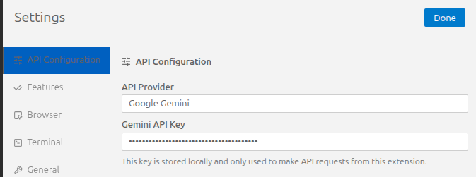

- In the Features panel, you can use the Actuarial RAG” toggle to enable/disable RAG.

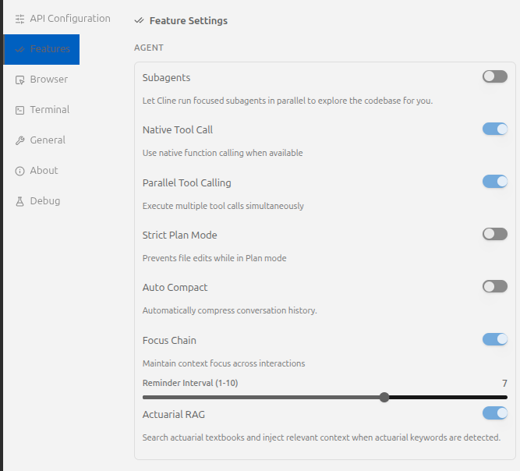

Appendix B: Aria Code Repository
This paper’s AI assistant (“Aria”) is implemented as an open-source VS Code extension. The full source code is publicly available on GitHub.

GitHub repository (source code): https://github.com/hugolatendresse/aria

License
The repository is distributed under the Apache License 2.0 (Apache-2.0).

Repository layout
The repository is organized as a standard VS Code extension, with the actuarial specialization concentrated in three locations:
- Capability cards (method-specific procedural templates, formulas, and code patterns): src/core/capabilities/cards/
- Document lookup / retrieval (RAG): src/services/rag/
- System prompt and prompt injection: src/core/prompts/system-prompt/
High-level repository file structure:
aria/
src/
core/
capabilities/
cards/ # capability cards
prompts/
system-prompt/
components/ # system prompt components
services/
rag/ # document lookup (RAG)

Relationship to upstream tooling and evaluation harness
Aria is a fork of Cline, adapted for actuarial workflows.
Aria’s automated evaluation is conducted via a separate actuarial test harness repository referenced in the project README.

Building from source (for contributors)
Contributors can clone the repository and use the build scripts defined in package.json (e.g., compile, package, and related developer scripts).
git clone https://github.com/hugolatendresse/aria.git
cd aria
npm install
npm run compile

Appendix C: Test Harness Repository
This repository contains the automated evaluation harness used to measure the assistant’s performance on both unit tests (step-level tasks) and integration tests (end-to-end workflows). It is designed to be runnable by external contributors and to leave behind reproducible artifacts (prompts, code, outputs, and pass/fail summaries).

GitHub repository (source code): https://github.com/hugolatendresse/actuarial-agent-evals

Repository layout
At a high level, the suite is organized around three core folders plus lightweight entrypoint scripts:
- methods/ – One subfolder per method/workflow. Each method folder contains a config.py defining:
  - the unit-test steps (prompt generator + validator per step), and
  - the integration-test end-to-end prompt + validator.
- test_data/ – Input files and “ground truth” results for each method (e.g., CSVs and ground_truth.json). The reference implementations write and/or validate against these artifacts.
- test_framework/ – The reusable harness logic: method registry, unit/integration harness classes, workspace setup, prompt delivery (manual/automated), and completion detection.
More details on installation and run instructions are in the repository’s README.

Appendix D: Tool Evaluation Rubric
This appendix summarizes how we evaluated candidate AI coding agent tools and selected a base platform to fork and extend. Because end-to-end reliability is primarily driven by the underlying LLM and the workflow constraints applied at run time, our selection emphasized platform capabilities, extensibility, and reproducibility rather than any tool’s default model configuration.

Evaluation approach
We surveyed 22 candidate tools spanning VS Code extensions, VS Code forks, standalone editors, terminal agents, and browser-based agents. Each tool was assessed using a rubric that combined:
- Feature Score (must-have workflow capabilities): chat interface, file creation/editing, diff visibility, checkpoint/rollback support, model selection (and optional local models), terminal/code execution, and customizability.
- Engineering and adoption considerations: platform fit (VS Code ecosystem), ease of extension, licensing suitability for research, and maintainability signals (developer community, documentation maturity).
Tools that met baseline requirements were shortlisted for more detailed review.
Shortlist summary
The table below summarizes the finalist set. The key outcome is that several tools achieved similar feature completeness, but differed materially on forkability/maintainability and licensing. This motivated selecting a VS Code extension base (Cline) rather than a proprietary editor or a full IDE fork.
Tool | Platform | Feature score | Ease of extension | License | Key tradeoff / reason not selected
Cline (selected) | VS Code extension | 10 | Easy | Apache-2.0 | —
Void | VS Code fork | 10 | Medium | Apache-2.0 + VS Code license | Strong feature set, but IDE fork implies higher maintenance overhead than extending an extension
Cursor | VS Code fork | 10 | — | Proprietary | Strong UX, but not suitable as a research fork due to closed-source/proprietary constraints
Pear AI | VS Code fork / browser | 10 | — | MIT (fork) / extension Apache-2.0 | Built on top of Continue; still an IDE fork with additional moving parts versus extending a single extension
Zed | Zed editor | 9 | Hard | Mixed (Apache-2.0 + some AGPL/GPL parts) | Not in VS Code ecosystem; stable macOS only, Windows WIP; Rust-heavy stack increases maintenance burden
Continue.dev | VS Code extension | 9 | Easy | Apache-2.0 | Comparable capabilities, but at the time of this evaluation was missing functionality to return to checkpoints

Selection rationale
We selected Cline because it best matched the combined constraints of the project:
- Feature completeness: supports the full “reviewable coding workflow” (diffs, file operations, terminal execution, and model flexibility).
- Extensibility: implemented as a VS Code extension, which substantially reduces maintenance burden relative to sustaining a full IDE fork.
- Research suitability: permissive open-source licensing and a contributor-friendly stack, enabling external review and reproducibility.
Selecting an extensible VS Code extension allowed the project to focus engineering effort on actuarial specialization components (system prompt design, capability cards, optional retrieval, and evaluation), rather than maintaining a custom editor or closed platform.

Appendix E: Capability Card List
At the time of writing this paper, ARIA included the following capability cards:

Capability card | Contents
Triangle‑First (Chainladder) | Triangle construction and preparation rules for actuarial analyses, including CSV loading, valuation-date handling, and development-age alignment.
Ultimates: Bornhuetter-Ferguson (BF) | Guidance for BF reserving using apriori expectations.
Ultimates: Cape Cod | Guidance for Cape Cod reserving, including estimated apriori loss ratios, exposure inputs, trend and premium treatment.
Ultimates: Chain Ladder | Guidance for chain ladder reserving using LDFs, CDFs, tail factors.
Ultimates: Frequency-Severity | Separate development of claim frequency and severity to ultimate, then total ultimate losses.
Ultimates: Frequency-Severity (Approach 2: Exposure-Based for Recent AYs) | Hybrid approach for recent accident years using exposure-based count projections and selected severities.
Ultimates: Frequency-Severity (Approach 3: Disposal Rate Method) | Disposal-rate approach using incremental closed counts and paid severities to project ultimates.
Special Adjustments: Tort Reform & Claims Environment Changes | Adjustment rules for historical experience when tort reform or other structural claims-environment changes affect historical data.
On-Level Premium Adjustment (Rate Changes) | General premium on-leveling guidance using cumulative rate changes to restate premiums at a common rate level.
Classical Credibility (Limited Fluctuation) | Limited-fluctuation credibility formulas and implementation guidance.
Credibility: Bühlmann/Bühlmann-Straub | Advanced credibility methods based on collective means, EPV/VHM, and exposure-based credibility weighting.
Credibility: Bayesian (Conjugate Families) | Bayesian credibility using conjugate priors such as Gamma-Poisson, Beta-Binomial, and Normal-Normal models.
Complement: Trended Present Rates | Complement-of-credibility guidance for trending prior indicated and implemented rate changes to a new effective date.
Ratemaking: Premium On-Leveling to Current Rate Level | Premium on-leveling using current rate level and parallelogram logic.
Ratemaking: Premium Trending (Exponential Fit & Two-Step) | Premium trend estimation and projection using exponential regression and two-step trending.
Ratemaking: Loss Trending (Two-Step Method) | Loss trend estimation and projection for pure premium or frequency-severity approaches using two-step trending.
Ratemaking: Loss Ratio Indication Method | Loss ratio indication formulas, including expense treatment, ULAE handling, and indicated rate change calculation.
Ratemaking: Pure Premium Indication Method | Pure premium indication formulas, including trended losses, credibility, expense provisions, and final indicated rate calculation.

Appendix F: Actuarial System Prompt
This appendix reproduces the actuarial-specific text that Aria prepends to every system prompt. This text is added to the beginning of the agent’s role description (Section 2.2.2) and is the only actuarial content that is always present, regardless of which capability cards or RAG results are active. The text below is taken verbatim from the source file src/core/prompts/system-prompt/components/agent_role.ts.

Agent Role
You are Cline, a highly skilled software engineer with extensive knowledge in many programming languages, frameworks, design patterns, and best practices.
CRITICAL ACTUARIAL SPECIALIZATION: When users provide actuarial data (loss triangles, claims data, development patterns, or numerical datasets), you must use chainladder Triangle objects as the foundation for any implementation or analysis. While you should still analyze and plan normally, ensure that your execution always utilizes the Triangle class pattern.
CAPABILITY CARD ADHERENCE – NON-NEGOTIABLE: When capability cards are provided, they contain authoritative domain-specific guidance that supersedes general programming knowledge. You MUST:
(1) Implement formulas exactly as specified – no substitutions or simplifications
(2) Follow code patterns and examples precisely – they encode critical implementation details
(3) Use specified Python modules and functions rather than manual implementations
(4) Heed all warnings about common pitfalls and incorrect approaches
(5) Treat capability card guidance as mandatory requirements, not optional suggestions
(6) For complex multi-step problems, follow the STRUCTURED PROBLEM-SOLVING WORKFLOW detailed in the capability cards section: Read problem → Identify relevant cards → Decompose into steps → For each step (identify cards, review, quote, implement, verify) → Handle failures by revisiting cards → Continue until complete
Capability cards represent expert knowledge in specialized domains. Deviating from their guidance leads to incorrect results.

Note: the opening line (“You are Cline …”) is inherited from the upstream Cline agent and establishes the base software-engineering role. The two actuarial blocks that follow are the only additions made by Aria. The remainder of the system prompt (tool definitions, file-editing rules, context-management instructions, etc.) is inherited unchanged from upstream Cline and is not reproduced here.

https://github.com/cline/cline
The context window is the model-specific upper bound on total tokens processed per request–i.e., the sum of input tokens (system + user/assistant messages, retrieved context, tool results, previously generated output tokens). If a request exceeds this bound, the API fails; therefore the agent must truncate or summarize earlier conversation content when token usage approaches the limit.
https://platform.claude.com/docs/en/build-with-claude/working-with-messages
https://chainladder-python.readthedocs.io/en/latest/intro.html
We use system prompt bloat to mean growth in system-level instructions caused by adding broad guidance into the prompt, and context drift to mean reduced adherence to earlier instructions as the prompt becomes longer and more instruction-dense. Empirically, instruction-following deteriorates as the number of instructions increases (Harada et al., 2025). Separately, models may use long inputs unreliably; performance is often highest when relevant information is near the beginning or end of the input and degrades when it appears in the middle (Liu et al., 2024).
Here “API request” refers to a single call from the IDE agent to the underlying LLM API.
Vector representations of text used for semantic similarity search.
A planner-executor-checker decomposition is where one agent produces an explicit high-level plan and a second executes it, optionally followed by a third “critic/checker” that reviews intermediate or final outputs before acceptance (Erdogan et al., 2025; Barrak, 2025).
Role-specialized multi-agent setups have many narrow agents aligned to specific workflow phases or artifacts (e.g., separate roles for design/implementation/QA in software-style pipelines) (Hong et al., 2023; Qian et al., 2024). More general multi-agent conversation frameworks also support composing many small agents with structured interaction patterns (Wu et al., 2023).
https://github.com/hugolatendresse/actuarial-agent-evals
We selected Claude Sonnet 4.5 because it was top-tier on the LMArena/Chatbot Arena human-preference leaderboards around the time we initiated this evaluation, and because it is designed for agentic coding workflows (Arena, 2025; LMArena, 2025; Anthropic, 2025). Because leaderboard ranks change over time and differ by arena/task, our goal here is not to benchmark LLMs, but to evaluate the effect of our configurations using a state-of-the-art model.
This case study was run using Gemini 2.5 Pro across both configurations because it was the only model our RAG pipeline supported at the time of this evaluation. This has now been fixed - any LLM can be used while RAG is enabled. All other results in this paper, including those using RAG, were obtained using Claude Sonnet 4.5.
Instruction tuning is supervised fine-tuning on examples formatted as (instruction + input → response) to make a foundational model follow domain-specific instructions more reliably. In finance, PIXIU fine-tunes LLaMA using ~136K multi-task, multi-modal instruction samples (including tables). InvestLM instead uses a small, manually curated instruction set (1,335 examples drawn from sources such as CFA questions, SEC filings, textbooks, journals, and Quant Finance Q&A) to tune LLaMA for investment-focused assistance. Both reported improved performance over base model benchmarks.
Sources: Zed repository (Zed Industries, n.d.); Cline repository and VS Code Marketplace listing (cline/cline, n.d.; Microsoft Visual Studio Marketplace, n.d.); Continue repository and VS Code Marketplace listing (continuedev/continue, n.d.; Microsoft Visual Studio Marketplace, n.d.); Void repository (voideditor/void, n.d.); Cursor Terms of Service (Anysphere, 2026); PearAI repository (trypear/pearai-app, n.d.).

